ADVANCED PROMPT ENGINEERING
PART B — PROMPT PORTFOLIO & AI-ASSISTED RESEARCH
Integrated AI Business Case Study | 10 Marks
Student Name | Harkirat Kaur Arora
Course | Introduction to Artificial Intelligence and Machine Learning
Selected Area | AI for Customer Support
Selected Company | Zomato
Part Covered | Part B — Prompt Portfolio & AI-Assisted Research

1. Part B Requirements Followed
The assessment requires important prompts used during research, at least one improved prompt, the AI tools used and their purposes, fact-checking with credible sources, and at least one critically evaluated AI response. fileciteturn1file1L125-L174
The Business Prompt Engineering lectures define the process as Business Problem → Required Information → AI Task → Prompt → AI Output → Human Review → Business Decision, and the framework contains Role, Context, Task, Constraints, Format and Check. fileciteturn1file0L13-L32 fileciteturn1file0L45-L59
The portfolio therefore uses one consistent business area and demonstrates prompt creation, refinement, evaluation, verification and human review.

2. Selected Business Problem
Business problem: Customer-support automation for an online food-delivery platform. The objective is to investigate how Generative AI can assist with routine customer queries while preserving human escalation for complex or high-impact issues.
The assessment explicitly lists customer-support automation and sentiment analysis among suitable AI/ML business problems and lists Generative AI/LLM and AI chatbot/assistant among possible approaches. fileciteturn1file1L34-L50 fileciteturn1file1L68-L79

3. AI Tools Used
Tool | Use | Evidence
ChatGPT | Prompt creation, refinement, structured business analysis and research planning. | 25 prompt evidence panels below
Google Colab | Simple reproducible checks and calculation/structure demonstrations. | Colab evidence panels below
The assessment permits tools such as ChatGPT, Claude, Gemini and Perplexity, but states that simply copying an AI-generated answer is not AI research. fileciteturn1file1L120-L149

4. Twenty-Five Prompt Portfolio Entries

Prompt 01 — Business Problem Prompt
Prompt used: Act as a business analyst. For an online food-delivery company, identify one specific customer-support problem that Generative AI could address. Explain who is affected and what business decision management needs to make.
Use / purpose: Defines the problem before asking AI for a solution, following the module's business prompting process.
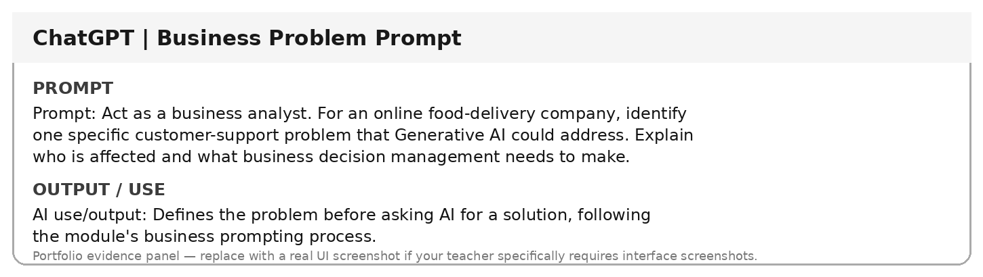

Prompt 02 — Focused Research Question
Prompt used: Convert the broad topic 'AI in customer support' into one focused research question for Zomato. Keep the question specific to customer-support automation and business impact.
Use / purpose: Produces a focused question suitable for the case study and keeps the research scope manageable.
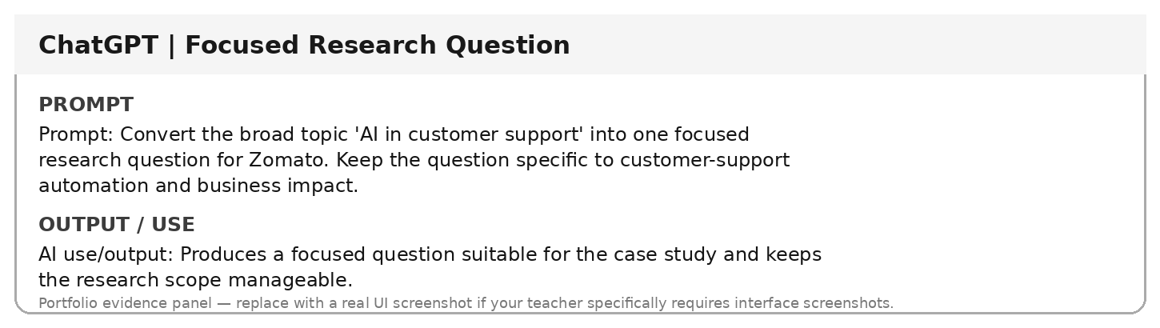

Prompt 03 — Role + Context
Prompt used: Act as a customer-experience manager for Zomato. The company handles customer queries about orders, refunds, payments and delivery issues. Explain where AI assistance could support customer service without replacing human judgment.
Use / purpose: Adds role and business context so the answer is directly relevant to the selected problem.
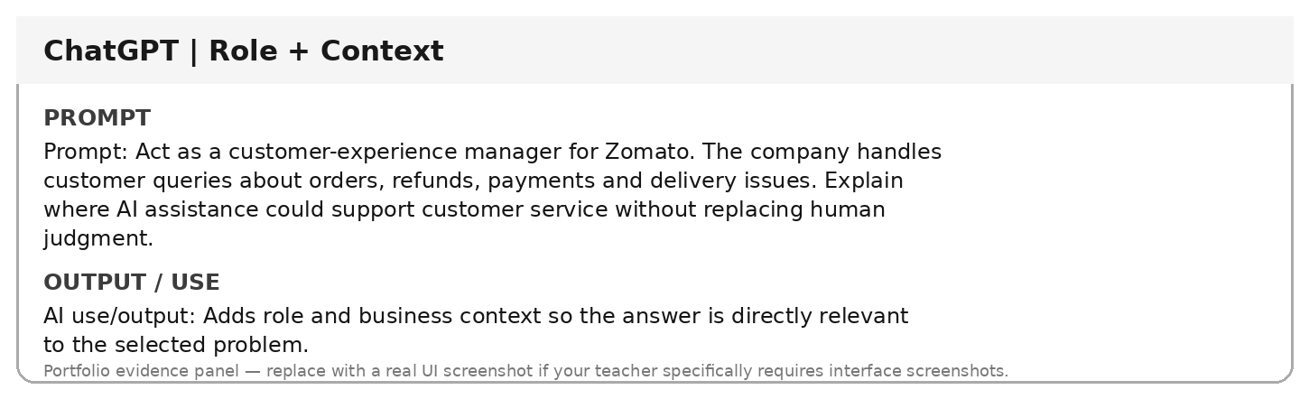

Prompt 04 — Marketing Prompt
Prompt used: Act as a marketing manager for a café near a university. Create a 7-day campaign to increase weekday visits from students aged 18–24. Budget ₹20,000; use Instagram, WhatsApp and in-store promotion; avoid expensive influencers. Present Day, Activity, Channel, Cost and Benefit in a table.
Use / purpose: Applies the exact Marketing framework from the course: role, context, task, constraints, format and assumptions.
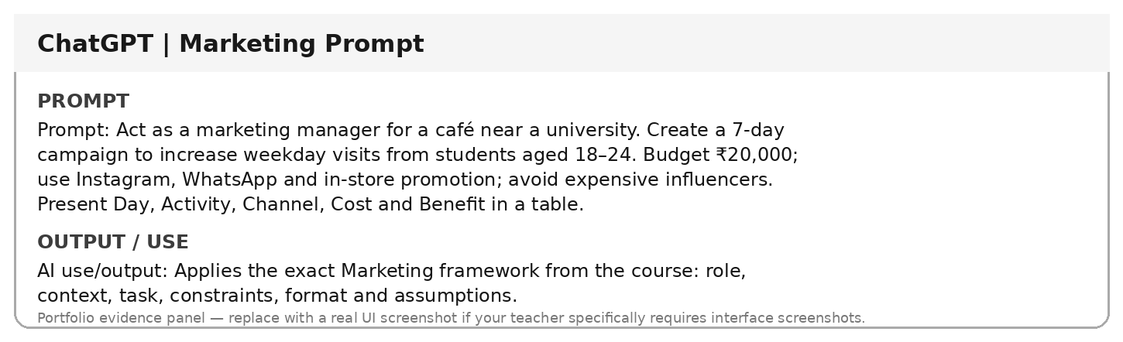

Prompt 05 — Marketing Refinement
Prompt used: Revise the café campaign prompt by adding this condition: the café does not provide home delivery. Keep the same budget and channels. Identify what changes in the campaign and why.
Use / purpose: Demonstrates prompt refinement and comparison of original vs revised output.
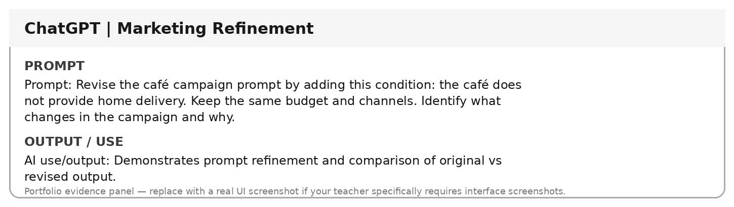

Prompt 06 — HR Interview Prompt
Prompt used: Act as an HR manager hiring a Digital Marketing Intern for an e-commerce company. Create 8 interview questions for a BBA student assessing communication, basic marketing knowledge, creativity, problem-solving and teamwork. Present question, skill tested and what a good answer demonstrates. Avoid personal or sensitive information.
Use / purpose: Generates structured, job-relevant interview questions while reducing unfair or irrelevant questions.
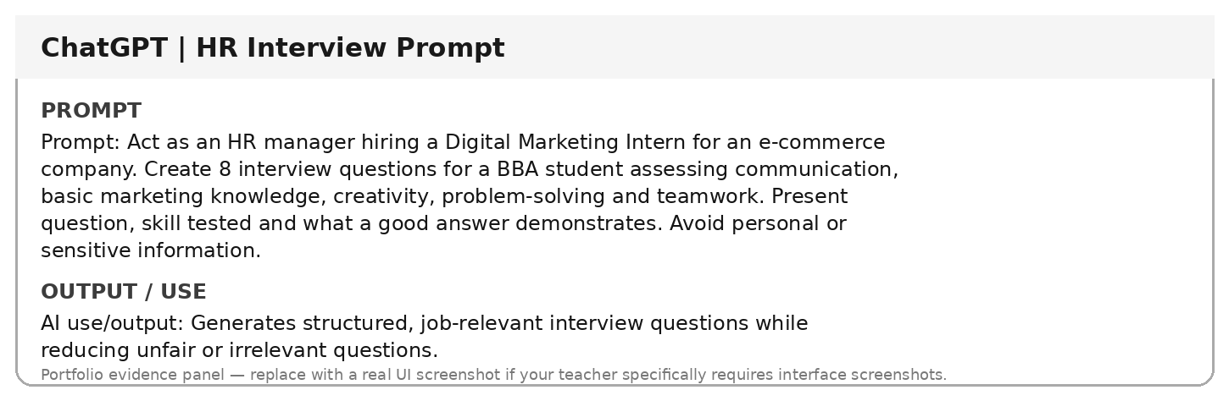

Prompt 07 — HR Bias Review
Prompt used: Review the following internship interview questions for bias, ambiguity and repetition. Identify problematic questions and suggest fair alternatives. Explain why an HR professional should still review the final set.
Use / purpose: Uses AI for HR assistance while keeping the final hiring responsibility with the human decision-maker.
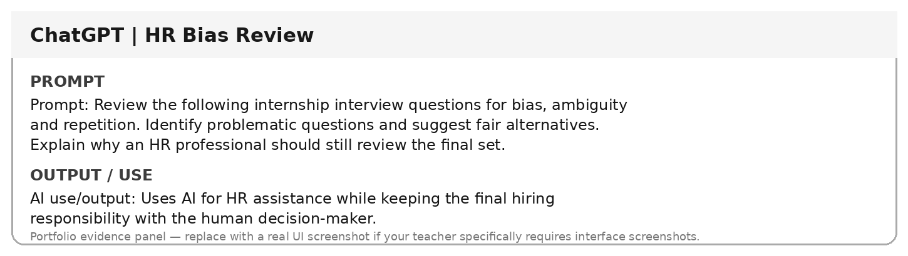

Prompt 08 — Finance Calculation Prompt
Prompt used: Act as a financial analyst for a small café. Using only: Revenue ₹5,00,000; Rent ₹80,000; Salaries ₹1,50,000; Ingredients ₹1,20,000; Electricity ₹25,000; Marketing ₹20,000; Other Expenses ₹30,000. Calculate total expenses, profit and profit margin. Separate calculations, observations and recommendations. Do not invent data.
Use / purpose: Tests controlled financial analysis with explicit data constraints.
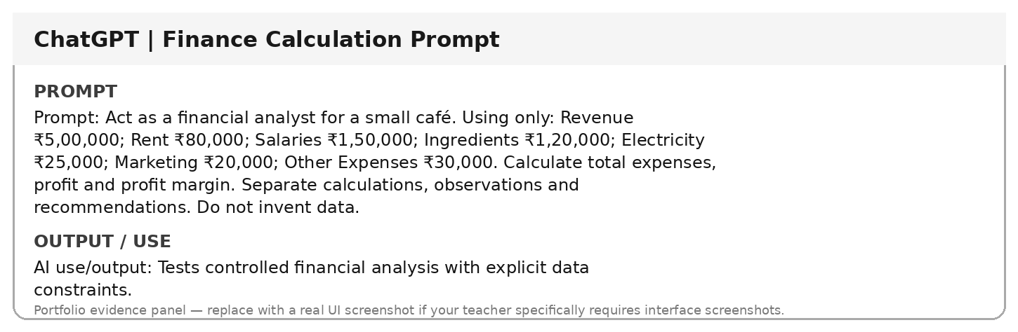

Prompt 09 — Finance Verification Prompt
Prompt used: Verify the café financial calculation manually. Show the total-expense addition, profit calculation and profit-margin formula. Flag any mismatch between AI output and manual calculation.
Use / purpose: Demonstrates independent checking of AI-generated financial calculations.
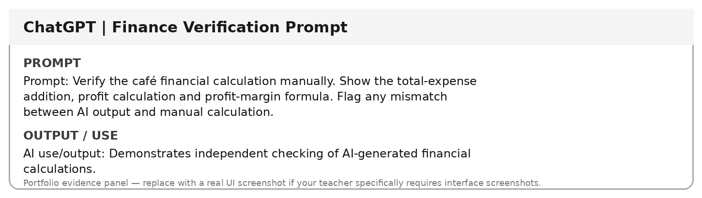

Prompt 10 — Operations Prompt
Prompt used: Act as an operations manager for an online retailer. Customers report late deliveries, damaged packaging, wrong products and slow refunds. For each issue give Possible Cause, Business Impact, Recommended Action and Suggested KPI in a table. Label assumptions.
Use / purpose: Converts an operations problem into a structured improvement plan.
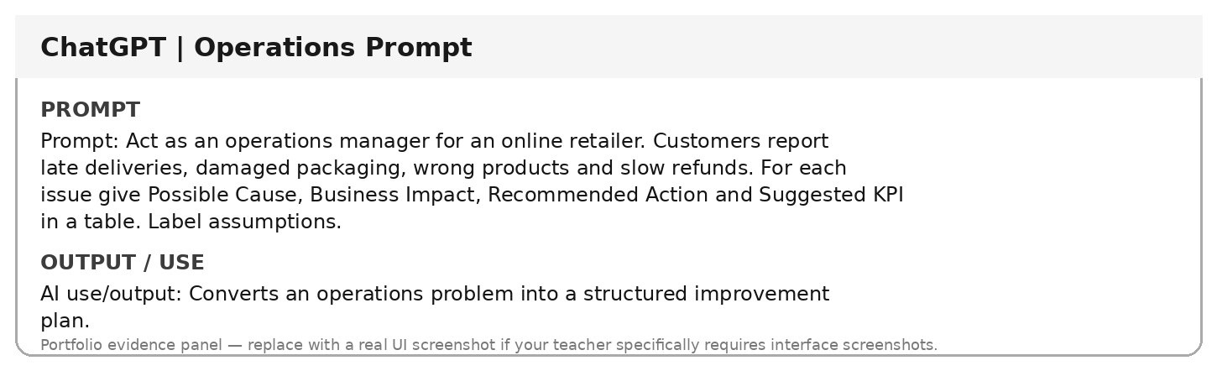

Prompt 11 — KPI Prompt
Prompt used: For late deliveries, damaged products, wrong products and slow refunds, identify one relevant KPI for each problem and explain what the KPI measures.
Use / purpose: Connects AI recommendations to measurable business performance.
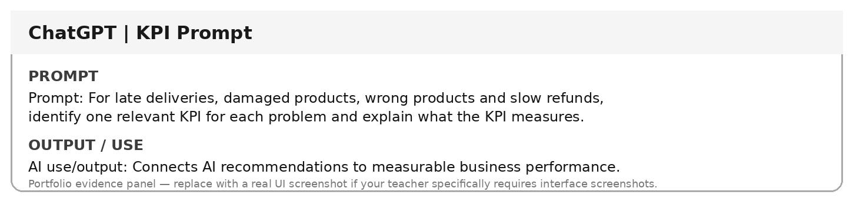

Prompt 12 — Operations Evaluation
Prompt used: Evaluate an AI-generated operations plan. For each recommendation, distinguish between fact, assumption and recommendation. Identify which actions need additional operational data before implementation.
Use / purpose: Builds critical evaluation into the prompt instead of accepting AI output automatically.
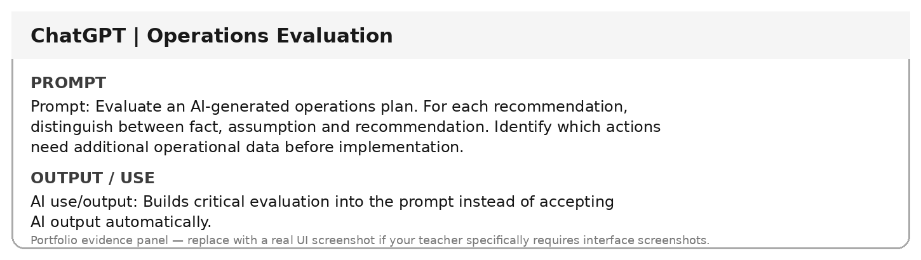

Prompt 13 — Cross-Functional Prompt
Prompt used: Act as a business consultant for StyleHub, an online fashion retailer. Problems: low repeat purchases, weak customer-service training, unnecessary costs and delivery delays. Create four separate AI prompts for Marketing, HR, Finance and Operations. Each must include Role, Context, Task, Constraints, Format and Verification.
Use / purpose: Demonstrates cross-functional business prompting using the six-element framework.
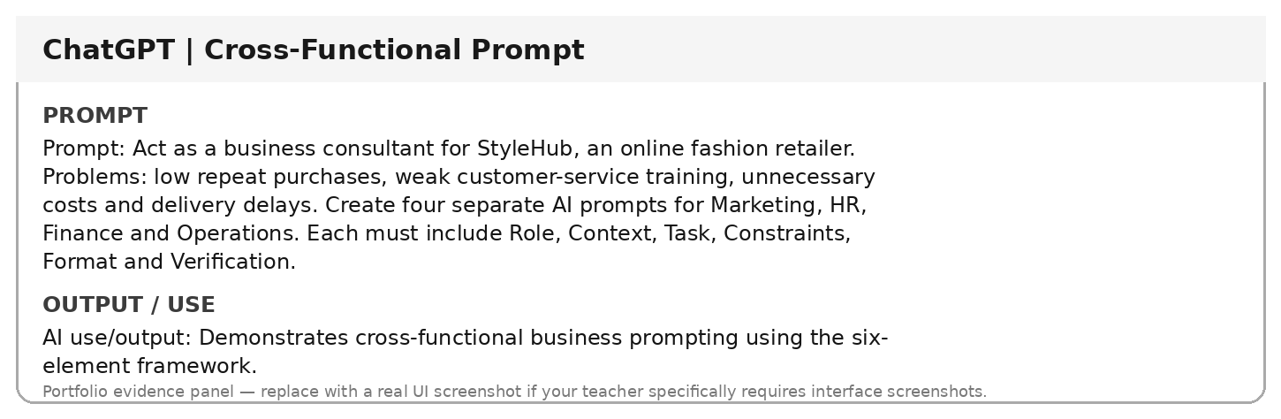

Prompt 14 — Decomposition Prompt
Prompt used: Break the customer-support automation problem into five smaller research questions. Do not answer them; only list the questions in a logical order.
Use / purpose: Uses decomposition to make a complex business problem easier to research.
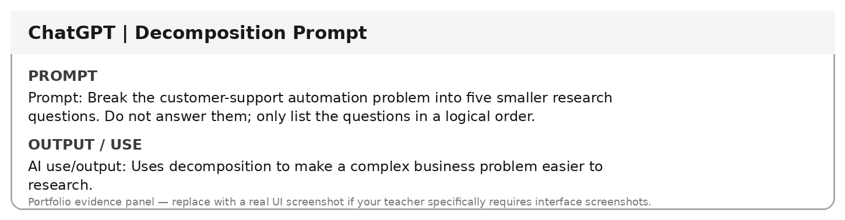

Prompt 15 — Prompt Chaining — Stage 1
Prompt used: Create a research plan for AI-based customer-support automation. Include subtopics, keywords, source types and evidence to collect. Do not invent sources.
Use / purpose: First stage of a prompt chain: research planning before drafting.
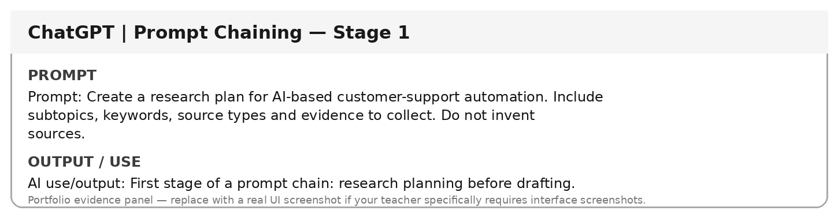

Prompt 16 — Prompt Chaining — Stage 2
Prompt used: Using the research plan, create an evidence table template with Claim, Source, Date, Verified?, Evidence/Notes and Use in Report?
Use / purpose: Second stage turns the research plan into an evidence-tracking structure.
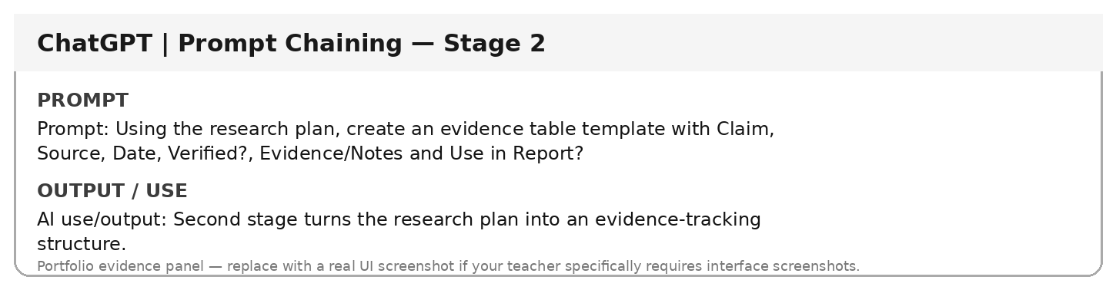

Prompt 17 — Source Verification Prompt
Prompt used: For any important claim about a company's AI use, explain how to verify it using an official company source, annual report, government source, research paper or reputed business publication. Do not treat AI-generated citations as verified until the original source is opened.
Use / purpose: Makes verification an explicit part of the AI-assisted research process.
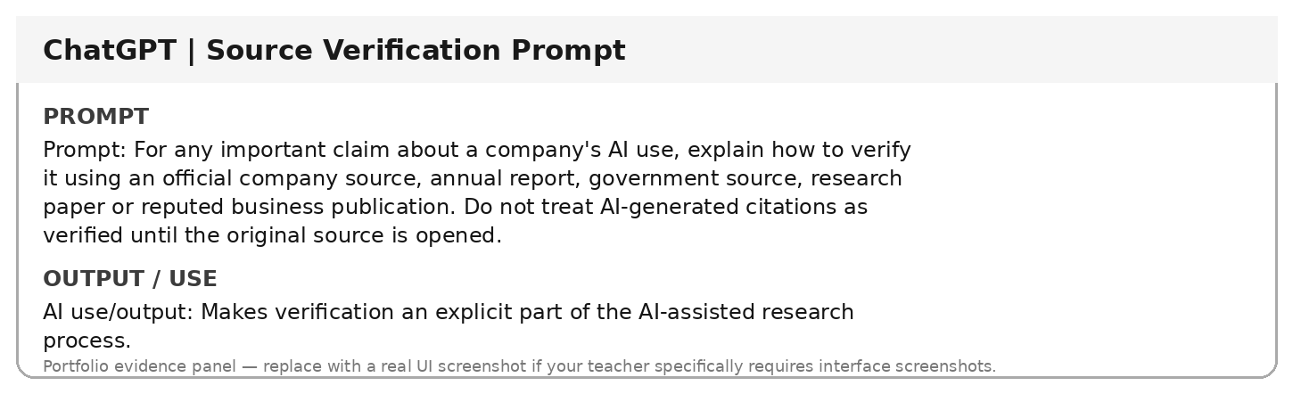

Prompt 18 — Fact vs Recommendation
Prompt used: Separate a business response into Evidence, Interpretation and Recommendation. Do not present recommendations as facts and flag statements that require external verification.
Use / purpose: Prevents mixing factual evidence with analysis and recommendations.
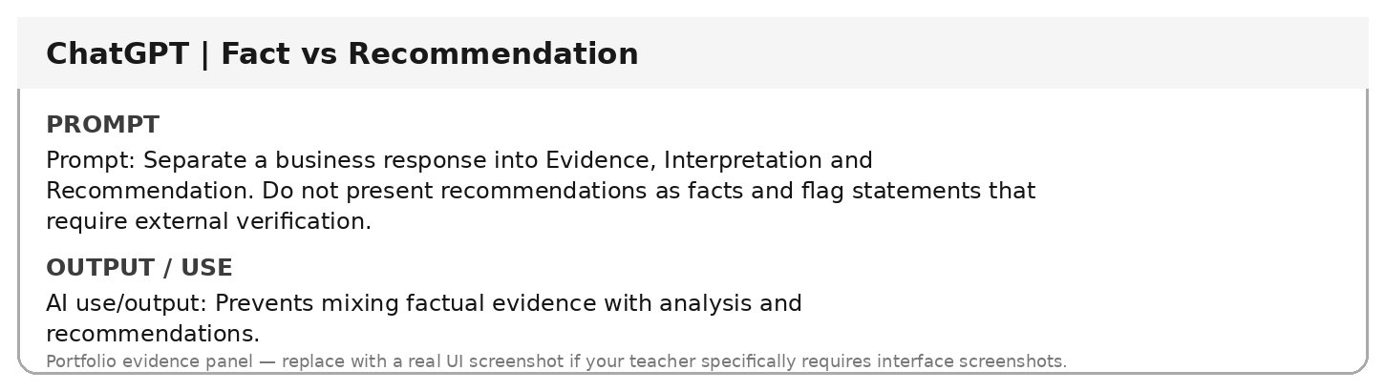

Prompt 19 — Comparative Analysis
Prompt used: Compare AI-assisted customer support and human-only customer support using Response Speed, Availability, Scalability, Complex Issues, Customer Trust and Human Oversight. Do not choose an overall winner.
Use / purpose: Creates a balanced comparison without asking AI to make the final management decision.
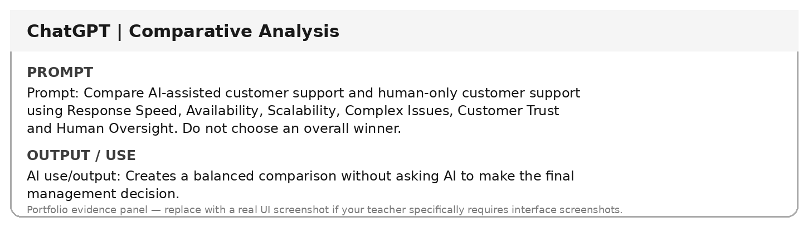

Prompt 20 — Edge-Case Prompt
Prompt used: List eight customer-support situations that should be escalated to a human instead of being fully automated. Explain the risk of automated handling for each.
Use / purpose: Identifies cases where human oversight is important.
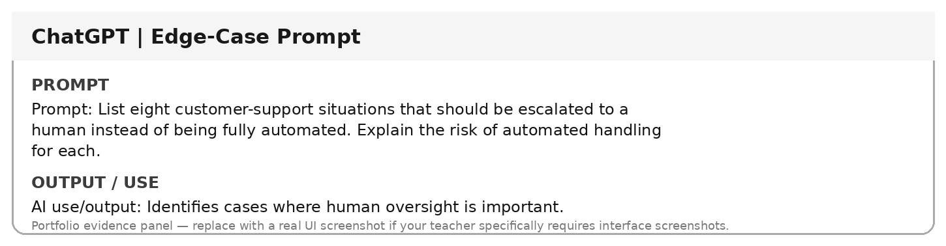

Prompt 21 — Constraint Prompt
Prompt used: Analyse an AI customer-support proposal under these constraints: no invented statistics, simple business language, clearly marked assumptions, human escalation for complex issues, and a table as the output format.
Use / purpose: Shows how constraints improve reliability and business usability.
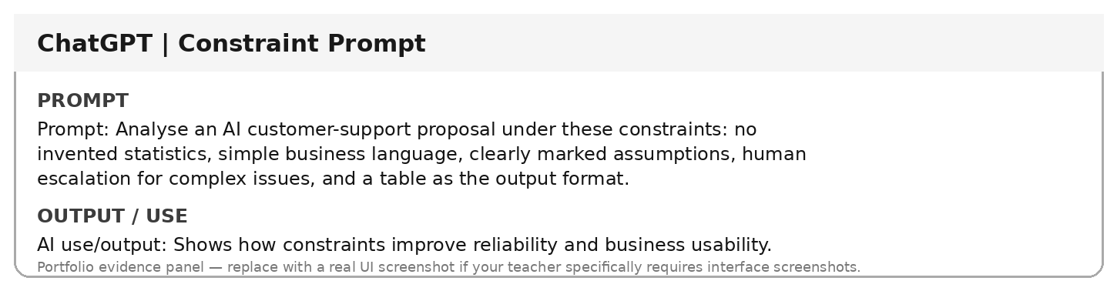

Prompt 22 — Critical Evaluation Prompt
Prompt used: Critique this weak prompt: 'Tell me about AI in Zomato.' Identify five missing elements and rewrite it using Role, Context, Task, Constraints, Format and Verification.
Use / purpose: Provides the required prompt-improvement evidence for the assessment.
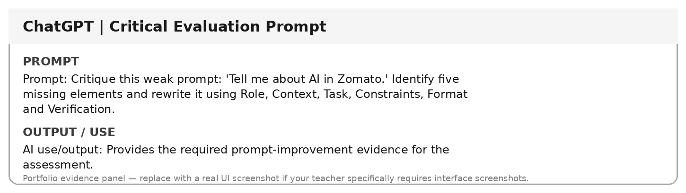

Prompt 23 — Weak Response Verification
Prompt used: A generic AI answer about AI in Zomato does not explain the selected customer-support problem, required data, risks or evidence. Explain how to verify its usefulness against the research question and how to improve the prompt.
Use / purpose: Documents the weak-output identification, verification method and correction process.
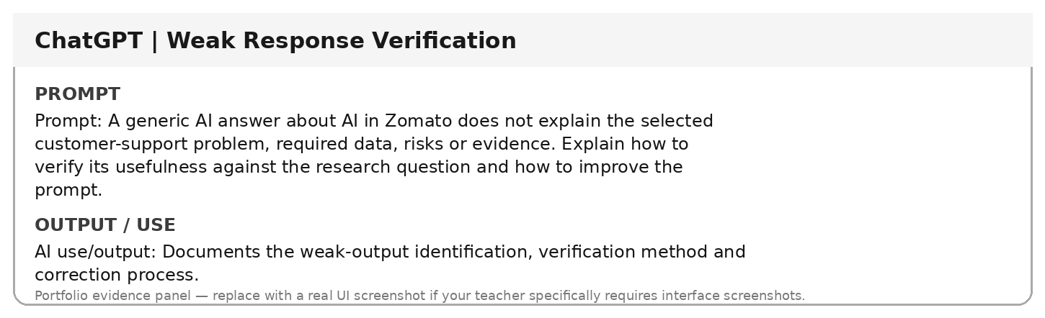

Prompt 24 — Final Recommendation Prompt
Prompt used: Act as a business research editor. Using only verified evidence supplied by the student, draft a concise recommendation for management. Separate Evidence, Business Implication, Risk and Recommendation. Do not add unsupported facts.
Use / purpose: Produces a final business recommendation while preserving human responsibility for the decision.
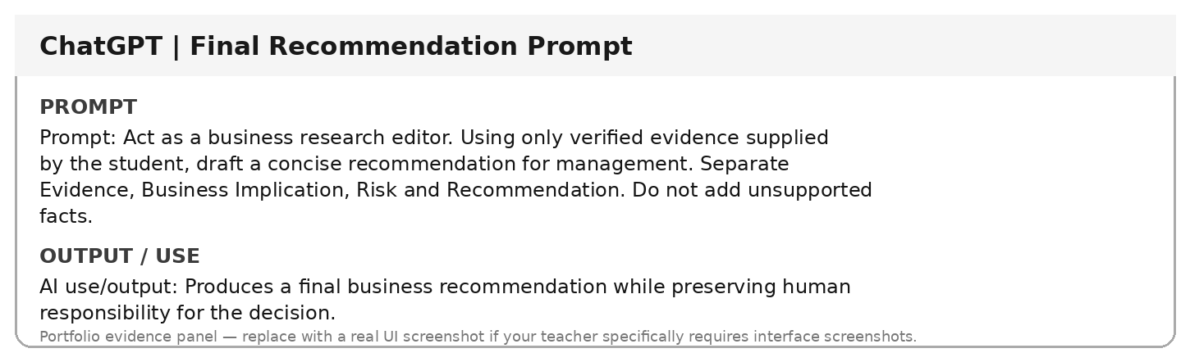

Prompt 25 — Master Portfolio Prompt
Prompt used: Act as a senior business research assistant. Help organize a Part B prompt portfolio for the selected business problem. Include important prompts, improvements, AI tools used, verification notes, critical evaluation, final recommendation and a 3–5 line reflection. Clearly distinguish AI-generated content from independently verified evidence.
Use / purpose: Integrates the complete Part B workflow into one reusable portfolio prompt.
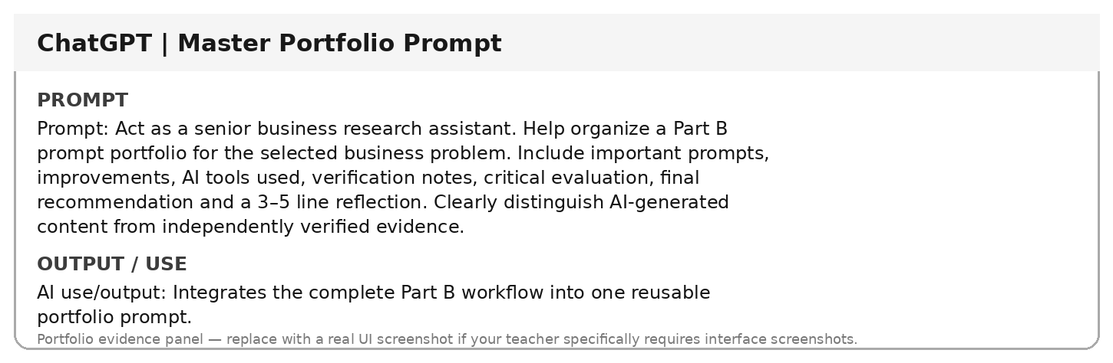

5. Prompt Improvement Evidence
The assessment specifically requires showing how at least one prompt improved during research and explaining why the improved version produced a better result. fileciteturn1file1L130-L141
Version | Prompt
Original / Basic | Tell me about AI in Zomato.
Improved | Act as a business analyst. Analyse how AI-based customer-support automation could improve customer experience for Zomato. Focus on routine query automation, human escalation and business impact. Use only supported information, clearly label assumptions, flag claims needing verification, and present the output in a table.
Why it is improved: it adds a clear role, business context, task, constraints, output format and verification requirement. This aligns directly with the six-part business prompt framework in Lectures 20–21. fileciteturn1file0L45-L59
Original output problem: a broad prompt can produce a general description rather than evidence that directly answers the selected business problem.
Improved output benefit: the response is narrower, more actionable and easier to evaluate against the business problem.

6. Critical Evaluation of a Weak AI Response
Weak prompt identified: “Tell me about AI in Zomato.”
Problem identified: the prompt does not specify the exact business problem, role, required data, constraints, output format or verification requirement. Therefore, the response can be too generic for a business case study.
How it is verified: compare the generated answer with the selected research question and the Part B requirements. Check whether it addresses the actual business problem, whether claims are supported by credible sources, and whether assumptions are clearly marked.
How it is corrected: replace the generic prompt with the improved version in Section 5 and rerun it. The assessment explicitly asks students to identify a response that may be incorrect, incomplete, outdated, too generic, biased, unsupported, or different from another source, and explain the verification and improvement process. fileciteturn1file1L161-L174

7. Google Colab Evidence
The following panels show simple code/output evidence created for this portfolio. For submission, the same code should be run in the student's own Google Colab notebook and the actual Colab screenshots can be inserted if required by the instructor.
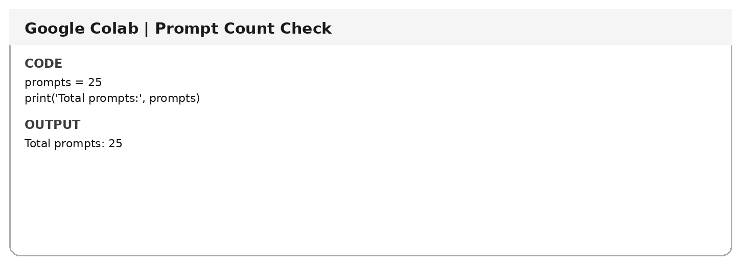

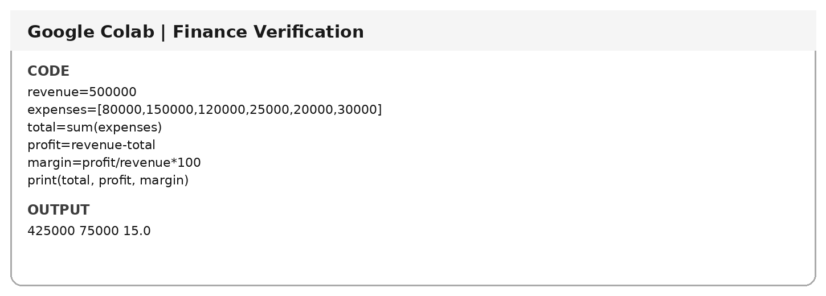

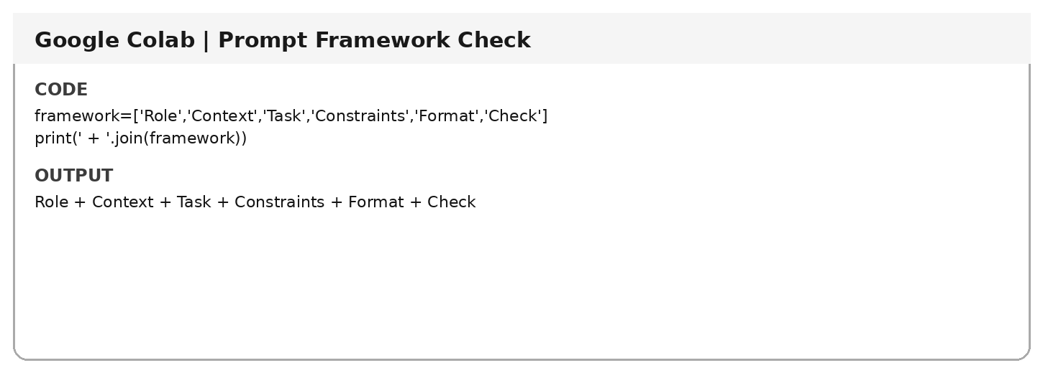

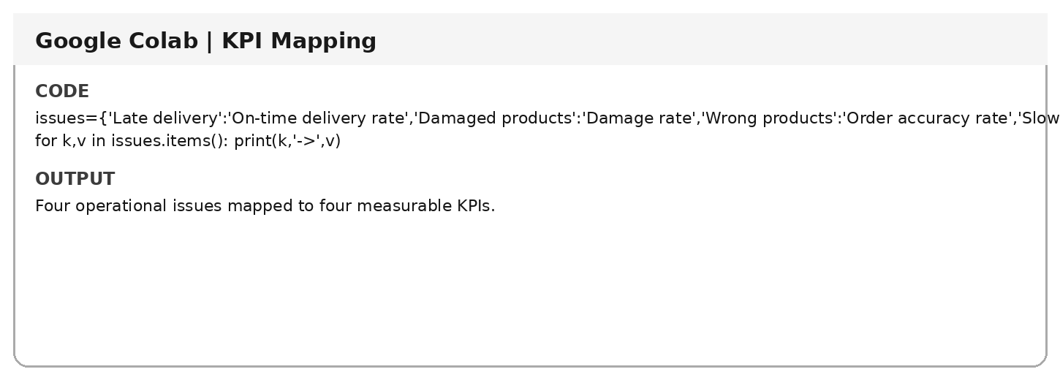

8. Fact-Checking and Source Verification
The assessment requires important facts to be verified using credible sources such as official company websites, annual reports, government websites, research papers, university/research publications and reputed business publications. fileciteturn1file1L150-L160
Claim | Source | Date | Verified? | Evidence / Notes | Use in Report?
[Complete after opening and checking original source] | [Complete after opening and checking original source] | [Complete after opening and checking original source] | [Complete after opening and checking original source] | [Complete after opening and checking original source] | [Complete after opening and checking original source]
[Complete after opening and checking original source] | [Complete after opening and checking original source] | [Complete after opening and checking original source] | [Complete after opening and checking original source] | [Complete after opening and checking original source] | [Complete after opening and checking original source]
[Complete after opening and checking original source] | [Complete after opening and checking original source] | [Complete after opening and checking original source] | [Complete after opening and checking original source] | [Complete after opening and checking original source] | [Complete after opening and checking original source]
[Complete after opening and checking original source] | [Complete after opening and checking original source] | [Complete after opening and checking original source] | [Complete after opening and checking original source] | [Complete after opening and checking original source] | [Complete after opening and checking original source]
[Complete after opening and checking original source] | [Complete after opening and checking original source] | [Complete after opening and checking original source] | [Complete after opening and checking original source] | [Complete after opening and checking original source] | [Complete after opening and checking original source]
This evidence table is intentionally left as a verification record rather than inventing company facts or citations. The assessment requires the references used for verification to be included in the presentation and GitHub repository. fileciteturn1file1L150-L160

9. AI Output Evaluation Checklist
- Business relevance — Does the response solve the actual business problem?
- Accuracy — Are facts and calculations correct?
- Feasibility — Can the recommendation realistically be implemented?
- Cost — Is the recommendation financially practical?
- Risk — Could the recommendation create problems?
- Ethics — Could anyone be treated unfairly?
- Evidence — Which claims require verification?
- Human judgment — What should the manager decide?
This checklist follows the lecture's business-prompt evaluation criteria. fileciteturn1file0L341-L359

10. Business Decision vs AI Output
AI output is not the same as a management decision. The lectures emphasize that important business decisions require context, policies, ethics, human judgment and accountability. AI should provide input; management remains responsible for the final decision. fileciteturn1file0L310-L340

11. Learning Reflection
I learned that advanced prompt engineering starts with a clearly defined business problem rather than simply asking AI a broad question. I learned how Role, Context, Task, Constraints, Format and Check make AI outputs more relevant and easier to evaluate. I also learned that AI-generated facts and calculations need verification and that human judgment remains necessary for important business decisions. Refining a generic prompt into a focused prompt improved the usefulness and structure of the resulting business analysis.

12. GitHub Evidence Checklist
- Prompt Portfolio
- Important original and improved prompts
- AI outputs and evaluation
- References/sources used for verification
- Learning reflection
- README.md
- Final PPT/PDF and Business Case Study / Research Report
The assessment requires every student to maintain an individual GitHub repository containing the project work and include the repository link on the final PPT slide. fileciteturn1file1L223-L249

13. Academic Integrity
AI is used as a research assistant, not as automatic evidence. The final work should reflect the student's understanding, and important facts, calculations and sources should be checked before submission. The assessment states that students must understand everything included in the project and maintain academic integrity. fileciteturn1file1L301-L323

